Incident Report
This form is to be completed for all incidents, injuries or illnesses, regardless of the extent or to whom the incident occurred and submitted as soon as practicable, but no later than 24 hours after the incident.
The Manager/Supervisor is to complete their section within 24 hours of the incident being reported.
NDIS Commission reportable incident | ☐ | Yes | ☐ | No

Employee to complete
Employee name
Participant name
Type of incident  (please select one) | ☐ Near miss  ☐ Injury  ☐ Illness  ☐ Property damage  ☐ Other (please specify):
Date of incident |  | Time of incident
Date incident reported |  | Time incident reported
Status of affected person | ☐ All About You – Disability Services employee  ☐ All About You – Disability Services participant  ☐ Other (please specify):
Where were you when the incident occurred
(please provide a location)
What were you doing at the time of the incident
(ie manual handling, active support, cleaning etc)
Provide a brief description of the incident
(ie what were the circumstances and what injury, if any, was sustained)
Were there any witnesses | ☐ Yes ☐ No | if Yes, please provide details below.
 | Witness name/phone
 | Witness name/phone
What do you think could be done to prevent this incident occurring again
Personal injury locations  (please select all that apply) | 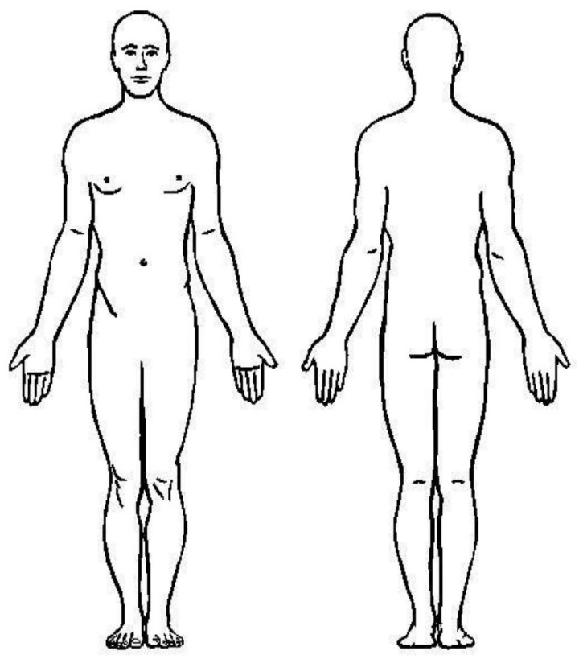  Please indicate with an X where incident occurred on body  ☐ Eye  ☐ Ear  ☐ Face  ☐ Head  ☐ Neck  ☐ Back  ☐ Torso  ☐ Shoulders & arms  ☐ Hands & fingers  ☐ Hips & legs  ☐ Feet & toes  ☐ Muscular/Internal  ☐ General and unspecified areas
Please provide any further details relevant to the injury
Could this incident have resulted on death, serious injury or both | ☐ Yes ☐ No  If Yes, was the incident reported to:  ☐ Manager  ☐ Other (please specify):
Signature |  |  | Date

Manager/Supervisor to complete
Outcome of incident  (please select all that apply) | ☐ No injury  ☐ First aid applied  ☐ Returned to normal duties  ☐ Medical treatment required (Doctor/Hospital)  ☐ Injury (returned to alternate duties)  ☐ Serious injury (off work)  ☐ Permanent injury  ☐ Property damage
Brief description of immediate preventative action taken
Is an investigation required | ☐ Yes ☐ No  If Yes, an Incident Investigation Form will need to be completed.
Have the relevant people been notified that the incident occurred | ☐ Yes ☐ No | if Yes, please provide details below.
 | Name
 | Position
 | Name
 | Position
What can be done to prevent future incidents of this nature
Has the employee received the appropriate documentation | Workers Compensation form/s: ☐ Yes ☐ No  Copy of Incident Report form: ☐ Yes ☐ No  If No, please provide details of the reason/s why:
Further details, including any follow up action/s
Signature |  |  | Date

